Panel Session

Aug 25th, 15:40 - 17:40
Chairs: Davies William de Lima Monteiro and Roberto Panepucci
"Product Development - Open Labs or Multi Project Wafer foundry runs?"

The panel will discuss opportunities presented by these two mechanisms of access to state-of-the-art technologies. These strategies of sharing infrastructure costs in microelectronics-related areas enable research and development leading to innovative products as well as science breakthroughs.
For almost 40 years, semiconductor companies and academia have understood the benefits of sharing NRE and depreciation costs of wafer runs for IC development cycles. With initial efforts in the US at MIT in 1978, and later funded by DARPA around 1981, MOSIS enabled multiple universities to demonstrate CMOS-based ICs exploring new computer architectures. At around the same time NORCHIP, CMP, and later EUROCHIP began offering MPW services globally, and currently there are over a few dozen such offerings through various brokers for a range of micro-scale technologies in many semiconductor platforms [1].
In 1976 NSF held three workshops across the US to assess the need and requirements for a university-based National Research and Resource Facility for Submicron Structures (NRRFSS). This was the first such initiative which led to the current NNCI - National Nanotechnology Coordinated Infrastructure. In such open-access user facilities, state-of-the-art equipment is accessible to outside users for hands-on development of novel devices. In the US alone there are over 40 such laboratories at universities, and several more at national facilities funded by the department of energy and the department of defense.
These two broad categories of technology facilitation have been stepping stones for innovative developments in industry and academia. The launch of deep-tech startups, as well as discoveries in a broad range of fields, from in biology, medicine, chemistry, to physics and engineering, would not have been possible without large scale efforts originated in microelectronics.
This year, the Chip-in-the-Fields Panel titled "Product Development - Open Labs or Multi Project Wafer foundry runs?" will bring together experts from both approaches. They will share current efforts to advance the offering of new technologies relevant for new developments using CMOS, MEMS, Photonics and more, more-than-Moore opportunities for researchers in Brazil and in the world.

This year´s panel will host:
Romano Hoofman from IMEC-Belgium – he will talk about foundry services on ´More-than-Moore´ technologies.
Michael Skvarla from CNF/NNCI – he will talk about open access usef facilities in the NNCI and the operation of the nanofabrication facility CNF at Cornell University
Ruben Sommer from CBPF/SisNano – he will talk about Brazil´s SisNano Open Lab initiative in Nanotechnology.
Flavio Plentz from UFMG - he will talk about startups making use of the available Open Labs and/or MPW runs to develop new products with partner companies.

[1] https://en.wikipedia.org/wiki/Multi-project_wafer_service

Biography of Panelists

Romano Hoofman
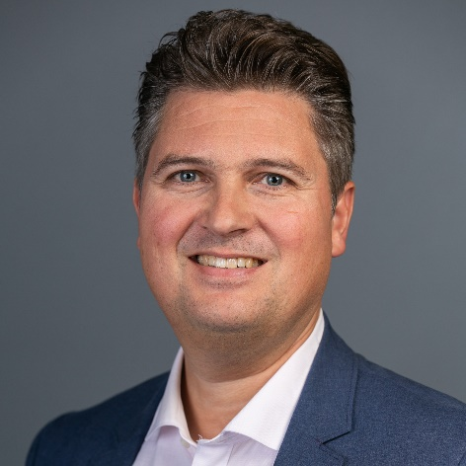
Romano Hoofman received the M.Sc. degree in molecular sciences from Wageningen University in the Netherlands in 1995 and Ph.D. degree in radiation chemistry from the Technological University of Delft, The Netherlands in 2000. He started his career in industry where he worked as a Principal Scientist at Philips Research and later on NXP Semiconductors. He covered many different R&D topics, ranging from CMOS integration, photovoltaic technology, thin film batteries and (bio)sensors. In May 2016, he took on the position as Strategic Development Director at imec Innovation Services and Solutions, where is responsible for the program management of EUROPRACTICE and related innovation services.

Michael Skvarla
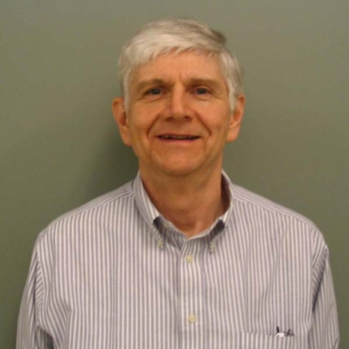
User Program Manager at the Cornell NanoScale Science and Technology Facility (CNF) of the NNCI - National Nanotechnology Coordinated Infrastructure, https://www.nnci.net/, and is responsible for the technical and administrative coordination of the CNF research program, involving several hundred active research projects and their associated personnel.
He received the Bachelor of Science in Physics from Wilkes University in Wilkes-Barre, Pennsylvania, and the Master of Science in Physics from Rensselaer Polytechnic Institute in Troy, New York. He joined the CNF in 1982, and has investigated all aspects of micro- and nano-fabrication technologies. He has been a part of the technical evolution of the CNF and currently works to introduce a varied population of researchers to the techniques of micro- and nano-fabrication as well as his own research projects.

Rubem Luis Sommer
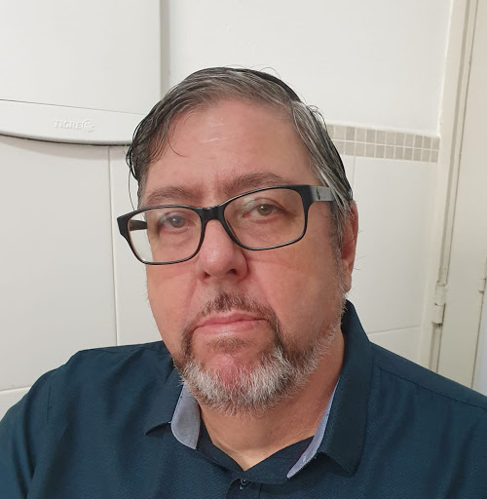
Bacharel em Física pela Universidade Federal do Rio Grande do Sul (1982), Mestre em Física pela Universidade Federal do Rio Grande do Sul (1986) e Doutor em Física pela Universidade Federal do Rio Grande do Sul (1992). Realizou estágio de pós-doutorado na Johns Hopkins University em Baltimore, Estados Unidos (03/1994-03/1996). Atualmente é Pesquisador Titular do Centro Brasileiro de Pesquisas Físicas (CBPF/MCT) e docente dos Programas de pós-graduação em Física do CBPF (Acadêmico e Profissional em Instrumentaçao Científica). Tem experiência na área de Física, com ênfase em Física da Matéria Condensada, atuando principalmente nos seguintes temas: processos de magnetização, estruturas de dominios magnéticos, permeabilidade, ruído Barkhausen, nanofabricação, materiais nanoestruturados, aços elétricos, materiais amorfos e ligas apresentando ordens magnéticas complexas, testes não destrutivos para aços estruturais na indústria do petróleo. É coordenador da Coordenação de Fìsica Experimental de Baixas Energias (EXP) do CBPF no período (2007-2011 e 2013- ) é Coordenador do LABNANO/CBPF (2012-) e Coordenador do Comitê Técnico do LABNANO/CBPF (2006-). É Coordenador do Laboratório de Magnetismo Aplicado e do Grupo de Magnetismo Aplicado da CBPF.
Flavio Orlando Plentz Filho
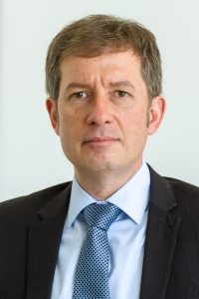
Possui graduação em Fisica pela Universidade Federal de Minas Gerais (1985), mestrado em Física pela Universidade Estadual de Campinas (1989) e doutorado em Física pela Universidade Estadual de Campinas (1993). Pós doutorado no Francis Bitter National Magnet Lad., no MIT, entre 1993 e 1995 em propriedades ópticas de gases de elétrons bidimensionais. Atualmente é Professor Associado IV da Universidade Federal de Minas Gerais. Atua em Física da Matéria Condensada principalmente em: (i) micro e nanofabricação, nanodispositivos em especial os baseados em grafeno; (ii) propriedades de transporte elétrico, propriedades ópticas e espectroscopia óptica em nanodispositivos semicondutores, nanotubos de carbono e grafeno; (iii) propriedades ópticas e magneto-ópticas e de transporte elétrico de materiais lamelares bidimensionais, especialmente os da família MX2 onde M é um metal de transição (Mo, W) e X um calcogênio (S, Se, Te); (iv) biosensores à base de grafeno. Foi Coordenador Geral de Micro e Nanotecnologias da Secretaria de Desenvolvimento Tecnológico e Inovação do MCTI entre Agosto de 2012 e Fevereiro de 2015. O principal foco atualmente é em projetos de inovação tecnológica.

